MNimize Fall Food Tour media kit

About the MNimize Fall Food Tour
This October, celebrate the first birthday of MNimize and get to know businesses that are reducing single-use plastic in your community by participating in the MNimize Fall Food Tour. Visit participating MNimize businesses from October 1 to 31, 2023 to be entered into a drawing to win one of five prizes. Look for the MNimize Fall Food Tour poster near the checkout counter or at the front of each business and scan the QR code to enter your information for a chance to win.

Resources to promote the MNimize Fall Food Tour
- Use the sample newsletter articles to share on your organization’s website or in your newsletters. These are editable so you can customize the length or message.
- Use the sample social media posts to share through your social media channels. These are editable so you can customize the message.
- Follow and reshare messages posted on MNimize social media channels: @mnimizeplastic on Instagram and MNimize on Facebook.
- Share the information and resources available and find participating businesses at mnimize.org/food-tour

Contact
For more information about the MNimize Fall Food Tour, contact:
- Keely Schultz, Sustainability Specialist, hello@mnimize.org

Newsletter article

Support eco-conscious eateries during the MNimize Fall Food Tour
This October, celebrate the first anniversary of MNimize and support businesses across the state that are taking action to reduce single-use plastic by participating in the MNimize Fall Food Tour! From coffee shops to breweries to bakeries, vegan fare to Somali cuisine to darn good burgers, MNimize businesses have something to offer every appetite with less plastic on the side.

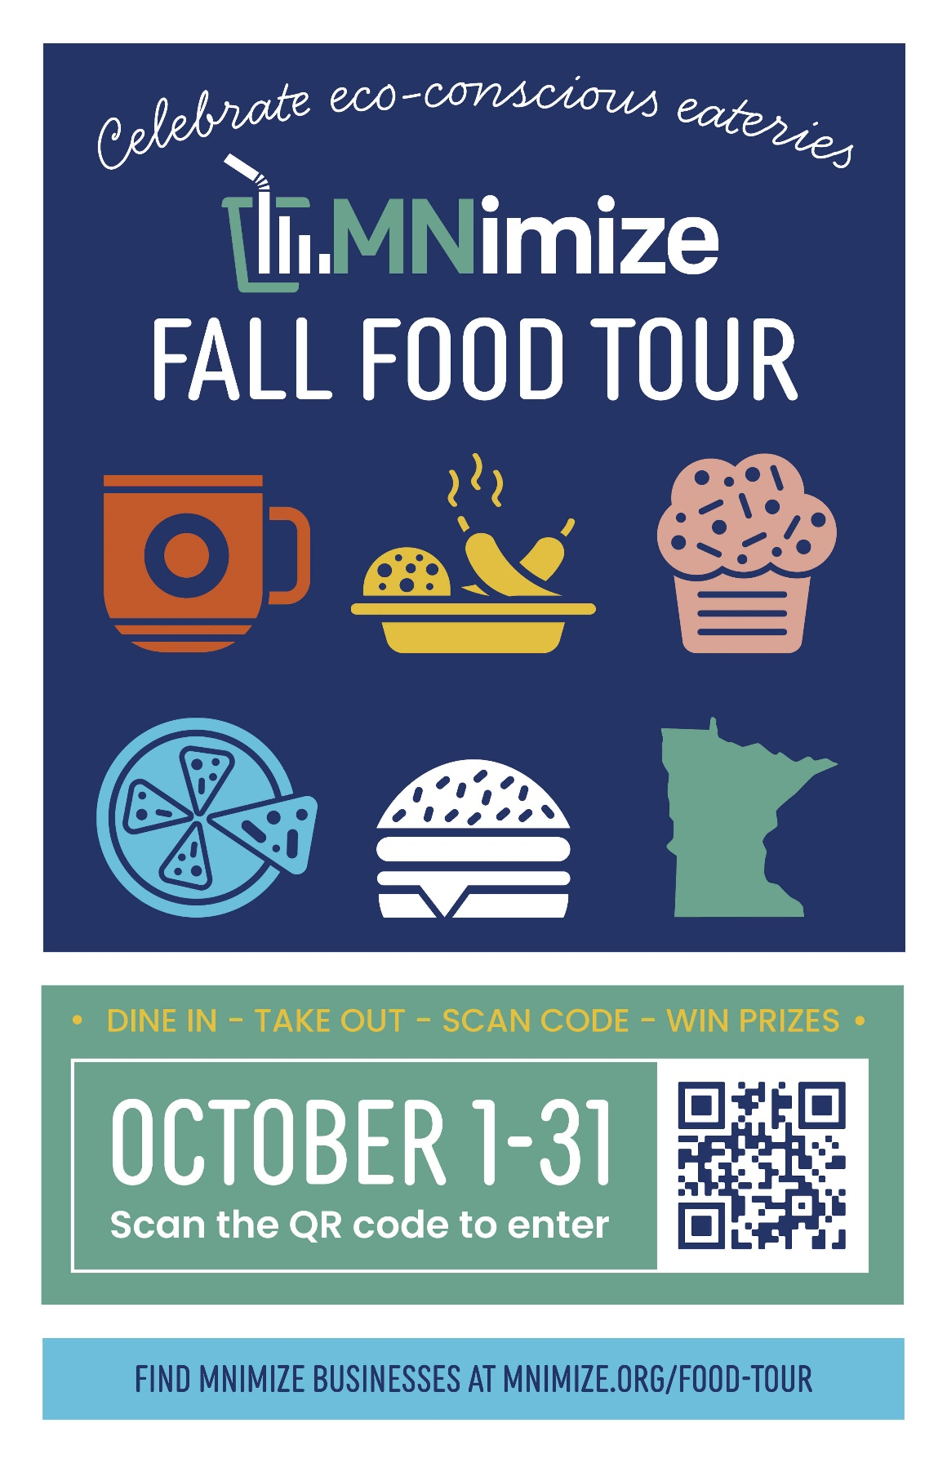
How to participate
Visit participating MNimize businesses from October 1 to 31, 2023 to be entered into a drawing to win one of five prizes. Look for the MNimize Fall Food Tour poster near the checkout counter or at the front of each business and scan the QR code to enter your information for a chance to win. Or, if QR codes aren’t your cup of tea, ask a staff member for our paper sign-in sheet to share your contact information.
During the MNimize Fall Food Tour you can also earn bonus entries by sharing an Instagram story or post with a photo you took at a MNimize business OR by resharing a post from @mnimizeplastic on your story to spread the word.
Be sure to follow MNimize on Instagram and tag us so we can count your entry and repost your photos!

Participating business
Find a list of all participating retailers at mnimize.org/food-tour
*This could be a good place to list businesses in your community

Prizes
First place (one available): $50 gift card to participating business of your choice
Second place (four available): $25 gift card to participating business of your choice

About MNimize
MNimize is a campaign to recognize and support Minnesota food service businesses as they take action to reduce disposable plastic. Launched as a partnership between Minnesota Waste Wise and Hennepin County, MNimize is now available to food businesses statewide that are interested in reducing single-use plastic. MNimize offers free one-on-one support to businesses to identify plastic reduction opportunities, connect with resources, and replace disposable plastics with reusable or certified compostable alternatives through our $500 rebate.

Learn more
Contact Keely Schultz hello@mnimize.org or 651-292-4664 if you have questions about the MNimize Fall Food Tour

Social media posts
Suggested hashtags: #MNimize #FallFoodTour #Sustainability #GreenRestaurant
To use images and graphics: right click on image and select ‘save as picture.’
Post 1: Support food service businesses working on reducing single-use plastic
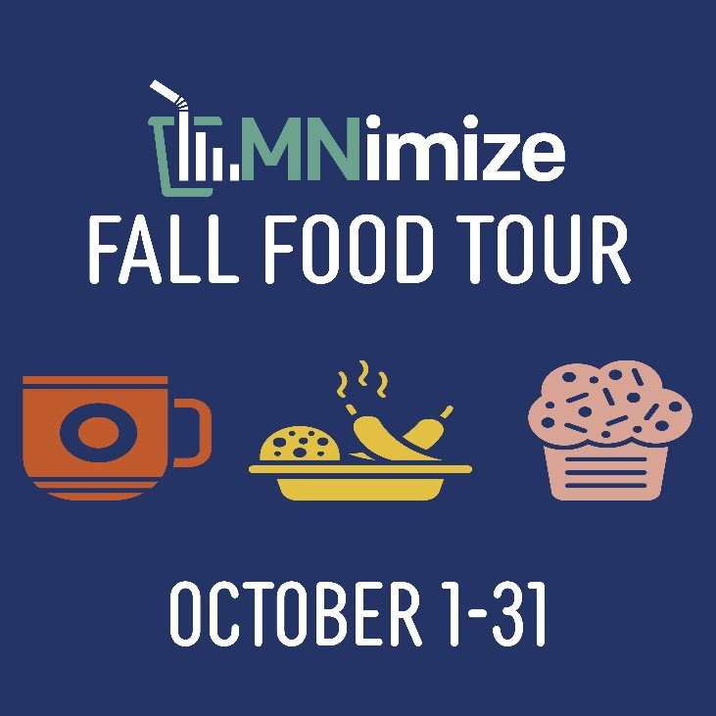
Facebook: This October, participate in the MNimize Fall Food Tour and get to know the food service businesses that are taking steps to reduce their use of single-use plastic! Visit a participating MNimize business between October 1 and 31st to be entered into a drawing to win one of five prizes. Look for the MNimize Fall Food Tour QR code at participating businesses. Find a list of businesses at mnimize.org/food-tour.
Instagram: This October, join the MNimize Fall Food Tour and discover food service businesses committed to reducing single-use plastic! Visit a participating MNimize business from October 1 to 31 for a chance to win one of five prizes. Keep an eye out for the MNimize Fall Food Tour QR code at participating spots. Explore the list of businesses at mnimize.org/food-tour.

Post 2: The problem of single-use plastic
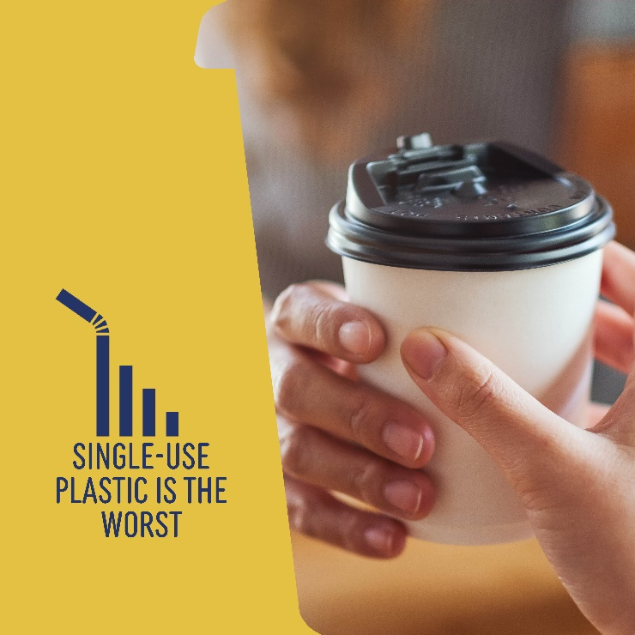
Facebook: Single-use plastics are designed for one-time use. Of the staggering 380 million tons of plastic produced annually, half is intended to be used just once. Some can be recycled, but most end up as waste in the landfill. Businesses participating in MNimize are working with a sustainability specialist to find alternatives to single-use plastic. For example, businesses can switch to reusable or compostable service ware products.
Instagram: Rethinking Single-Use Plastics
Did you know that of the whopping 380 million tons of plastic produced each year, half is designed for single-use? While some get recycled, most sadly find their way to landfills.
But here's the bright side! Businesses in the MNimize program are teaming up with sustainability experts to bid farewell to single-use plastics. One fantastic solution? Switching to reusable or compostable service ware products, taking a bold step toward a sustainable future.

Post 3: Participating in the MNimize Fall Food Tour (FOR PARTICIPATING MNIMIZE BUSINESSES)
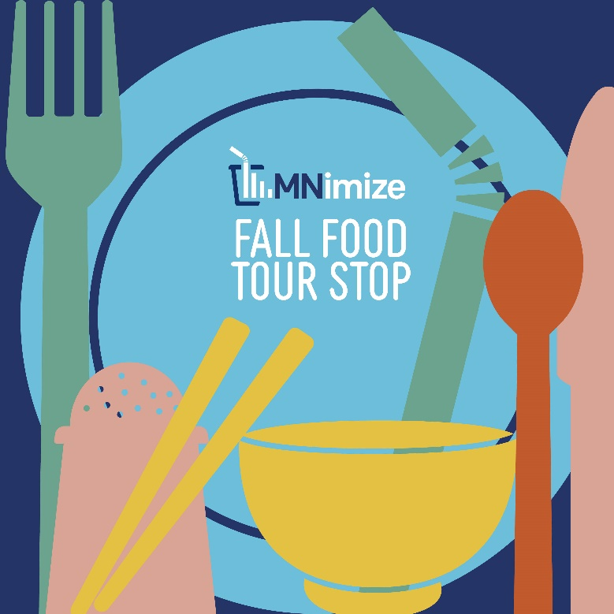
Facebook: We're thrilled to be a part of the MNimize Fall Food Tour!
From October 1st to 31st, explore the delicious flavors of sustainability as we join forces with other eco-conscious food service businesses to reduce single-use plastic.
Here's how you can be a part of the eco-foodie fun:
Visit us during October to enjoy our delicious dishes.
Look for the MNimize Fall Food Tour QR code in our establishment.
Scan the code for a chance to win prizes.
Support our commitment to reducing plastic waste and promoting eco-friendly practices.
Instagram: Exciting news, Instagram foodies! We're thrilled to be a part of the MNimize Fall Food Tour!
From October 1st to 31st, indulge in the delectable world of sustainability as we join hands with eco-conscious food service businesses to reduce single-use plastic.
Here's how you can join the eco-foodie fun:
Visit us throughout October to savor our sustainable delights.
Keep an eye out for the MNimize Fall Food Tour QR code in our spot.
Scan the code for a chance to win some fantastic prizes.
Support our dedication to reducing plastic waste and embracing eco-friendly practices.

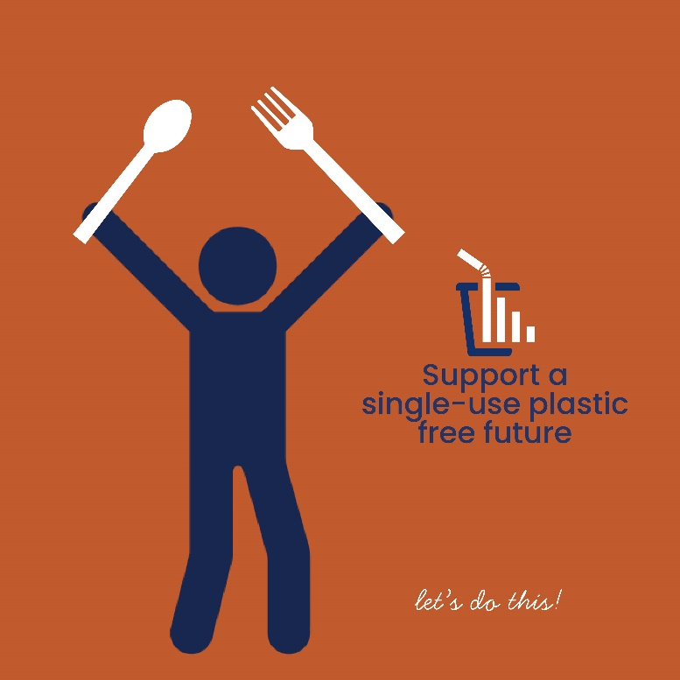
Post 4: Support businesses working toward sustainability
Facebook: Choose to dine with purpose! Supporting food service businesses that actively reduce their single-use plastic usage isn't just about enjoying a meal. It's a commitment to a greener, more sustainable future! By patronizing these eco-conscious eateries, you're endorsing their efforts to minimize waste, protect our environment, and inspire positive change within the industry. Every plate and cup count, and together, we can make a substantial impact on reducing plastic pollution.
Instagram: Dine with Purpose! Supporting food service businesses on a mission to reduce single-use plastic isn't just about enjoying a delicious meal. It's a commitment to a greener, more sustainable future! When you choose these eco-conscious eateries, you're endorsing their efforts to minimize waste and protect our environment. Every plate and cup count in our fight against plastic pollution!

